Name of Project: Contractor Name:-
Sr.No:- Date:-
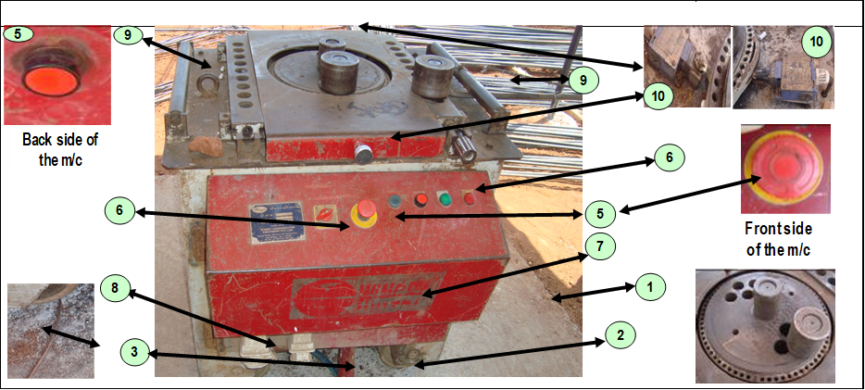

Sr.No | Check Point | Y/N/NA | Remark
1 | Erected in a firm base concrete platform.
2 | Machine is grouted properly/ Base wheel stopper provided.
3 | Body Earthing is provided.
4 | D.B box connected with the machine is equipped with MCB and ELCB.
5 | Power on & off switch with indicator light are available in working condition.
6 | Emergency switch is available in working condition ( Front side and back side )
7 | Limit switch (Both Side,below the job plate) are in working condition.
8 | Belt and other internal moving parts are covered/Guarded.
9 | No oil leakage.
10 | Both side hand guard is available.
 |  | Name | Signature
Checked by Electrician
Checked by P & M Incharge
Verified by EHS Officer


